**LAPORAN PRAKTIKUM PEMROGRAMAN 2**

**Belajar String**

Nama : Sukiyatno Nugroho

NIM : 4509210024

Praktikum

1. Ketik : mvn archetype –DgroupId=belajar.string –DartifactId=belajar-string

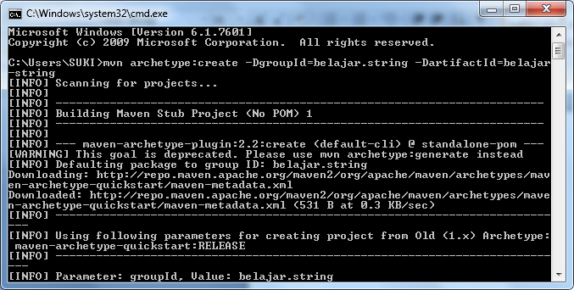

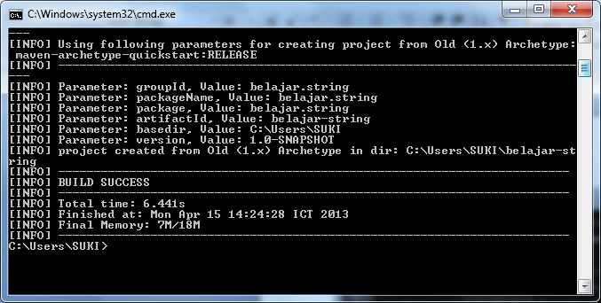

Mvn clean package exec:java –Dexec mainClass=belajar.string.namaclass

Latihan1.java

package belajar.string ;

public class Latihan1{

public static void main (String [] args){

String nama1=new String("tingki wingki");

System.out.println("Nama1 : "+nama1);

String nama2="lala";

System.out.println("Nama 2 : "+nama2);

}

}

Mvn clean package exec:java –Dexec.mainClass=belajar.string.Latihan1

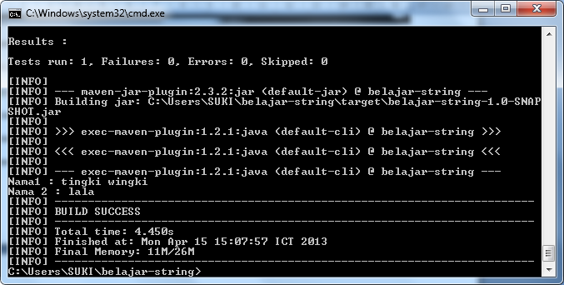

Latihan2.java

package belajar.string;

public class Latihan2{

public static void main(String [] args){

String s1="Go to";

String s2="Universitas Pancasila";

System.out.println (s1.concat(s2));

}

}

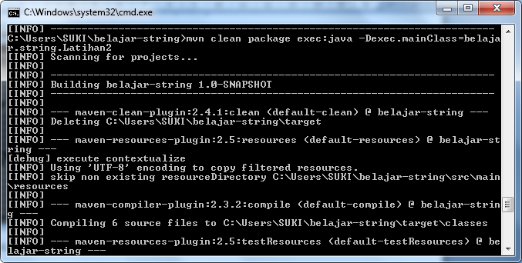

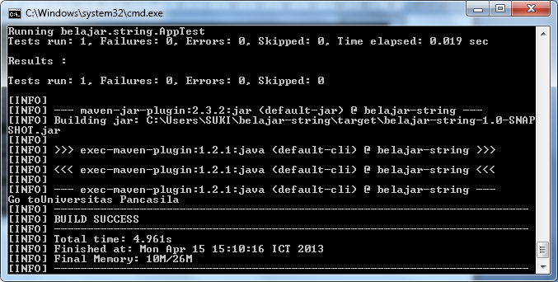

Latihan3.java

package belajar.string;

public class Latihan3{

public static void main (String [] args){

String text="Welcome to universitas pancasila";

System.out.println(text.substring(5));

String text2="Ayo kuliah";

System.out.println(text2.substring(4,8));

}

}

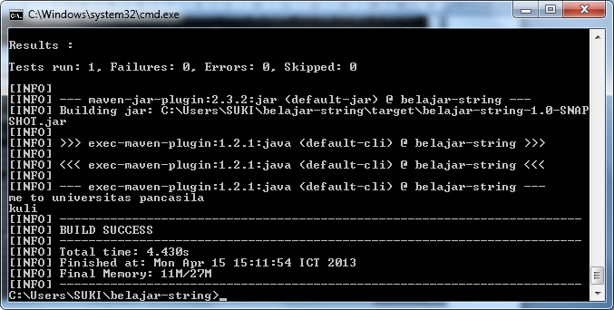

Latihan4.java

package belajar.string;

public class Latihan4{

public static void main (String args[]){

System.out.println (getReturn());

}

public static boolean getReturn(){

String s1="Hello";

String s2="Java";

if(s1==s2){

return true;

}

if (s1.equals(s2)){

return true ;

}

if (s1.compareTo(s2)==0){

return true;

}else{

return false;

}

}

}

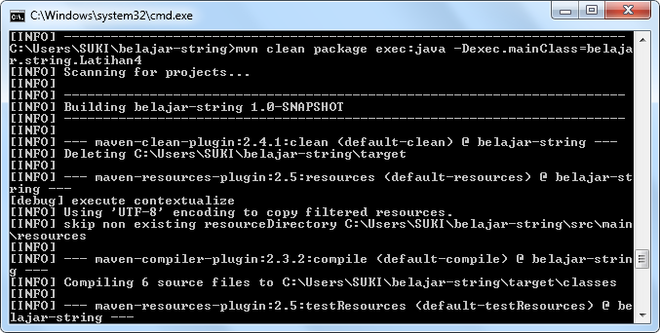

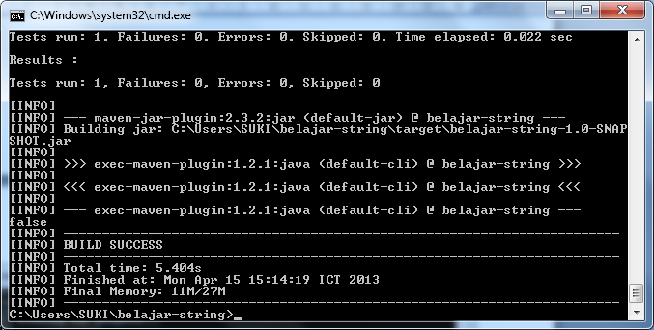

Latihan5.java

package belajar.string;

public class Latihan5{

public static void main (String args[]){

String text="Hello World";

System.out.println(text.toLowerCase());

}

}

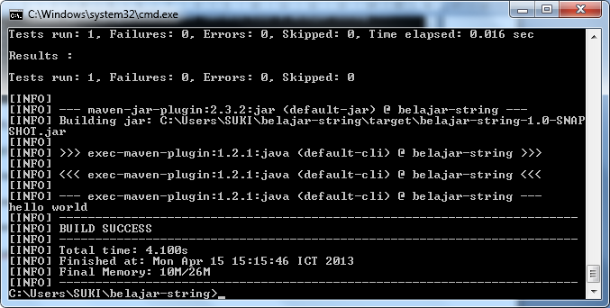

Latihan6.java

package belajar.string;

public class Latihan6{

public static void main (String [] args){

String text="Hello World";

System.out.println (text.toUpperCase());

}

}

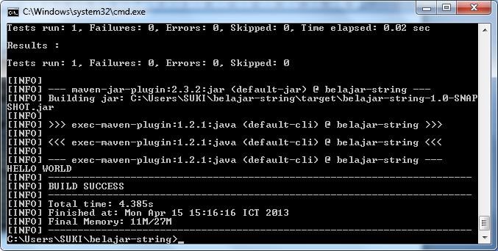

Membuat database

C:\xampp\mysql\bin\mysql\bin\mysql –u root

Lalu ketik create database p2;

Setelah itu

Use p2

create table produk( Id int (11) auto_increment primary key, Nama varchar(255), Harga decimal(10,2),);

